**CSCI 2302**

**Exception Handling Chapter**

**Defining Your Own Class Lab**

Contents

Purpose 1

Learning Goals 1

Notes 1

Task 1

Input 3

Output 3

Sample run 4

Submit 4

Purpose**:** Work with exception handling and files

Learning Goals:

Exception Handling enables a program to deal with runtime errors and continue its normal executions. Exception handling enables a method to throw an exception to its caller.

Implement exception handling into creating objects that use user input to instantiate so that only valid objects will be instantiated.

Notes**:** Please see Exception Handling Notes.docx found on the Content Page.

Task**:**

1. Download ExceptionHandlingDefineOwnClassLab.java and ehIn.txt files.
   1. ExceptionHandlingDefineOwnClassLab.java reads from the ehIn.txt file and tries to create triangles.
2. Save the ExceptionHandlingDefineOwnClassLab.java with mySFAUsername_ ExceptionHandlingDefineOwnClassLab.java.
3. In a triangle, the sum of any two sides has to be greater than the other side; your class must abide by this rule.
   1. Define/Create an IllegalTriangleException class to throw an IllegalTriangleException object if the input received to create a triangle will violate that rule.
   2. Modify Triangle.java, so that when you are creating a Triangle object, it throws an IllegalTriangleException when it does not abide by the rule.

(See the Exception Handling notes ExceptionHandlingNotes.java for some more examples; this can be accomplished in the constructors or the setters.)

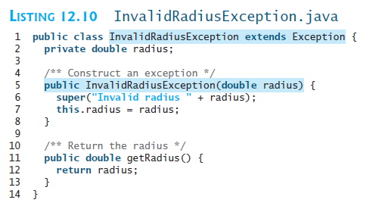

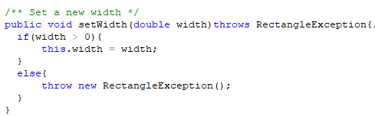

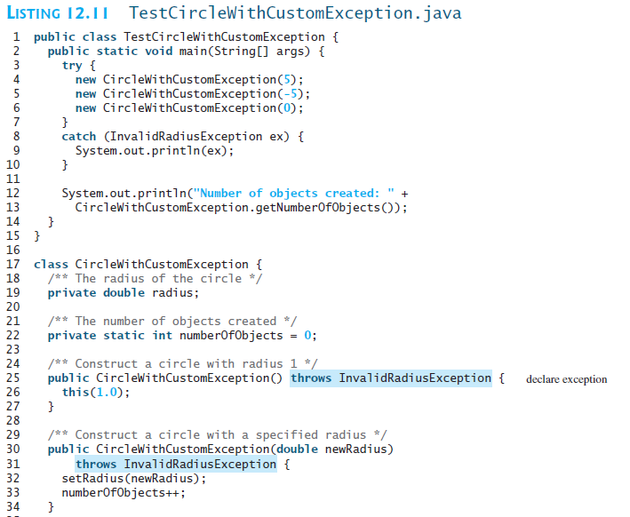

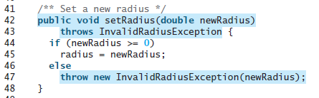

1. Run mySFAUsername_ ExceptionHandlingDefineOwnClassLab.java and make sure that you are understanding how this implementation is working.

Input**:** ehIn.txt - doubles

Output**:** to the screen

Sample run**:**

Trying to construct a triangle

With sides: 5.0, 6.0, and 7.0, the color is: purple

Perimeter for triangle: 18.0

Area for triangle: 14.70

Trying to construct a triangle

With sides: 4.0, 8.0, and 2.0, the color is: yellow

Illegal triangle - can't construct a triangle with given sides.

The sum of any two sides has to be greater than the other side

Side1: 4.0

Side2: 8.0

Side3: 2.0

Submit: the mySFAUsername_ExceptionHandlingLab.java, Triangle.java and the IllegalTriangleException.java in the Dropbox.